EARLY HISTORY
The Astronomy Program was established in 1962 as a separate degree granting unit of the then renamed Department of Physics and Astronomy. Gart Westerhout was the first Director of the Program. The Observatory was opened two years later in 1964. The short time interval implies that plans and proposals for the observatory began when the Program was established and may in fact have preceded the Program. The formal dedication was in November, 1964 with Wilson Elkins President of the College Park campus presiding (Fig 1). At the time of the dedication there were two telescopes – the 20” Bent Cassegrain Reflector telescope and a 8” reflector of similar design.
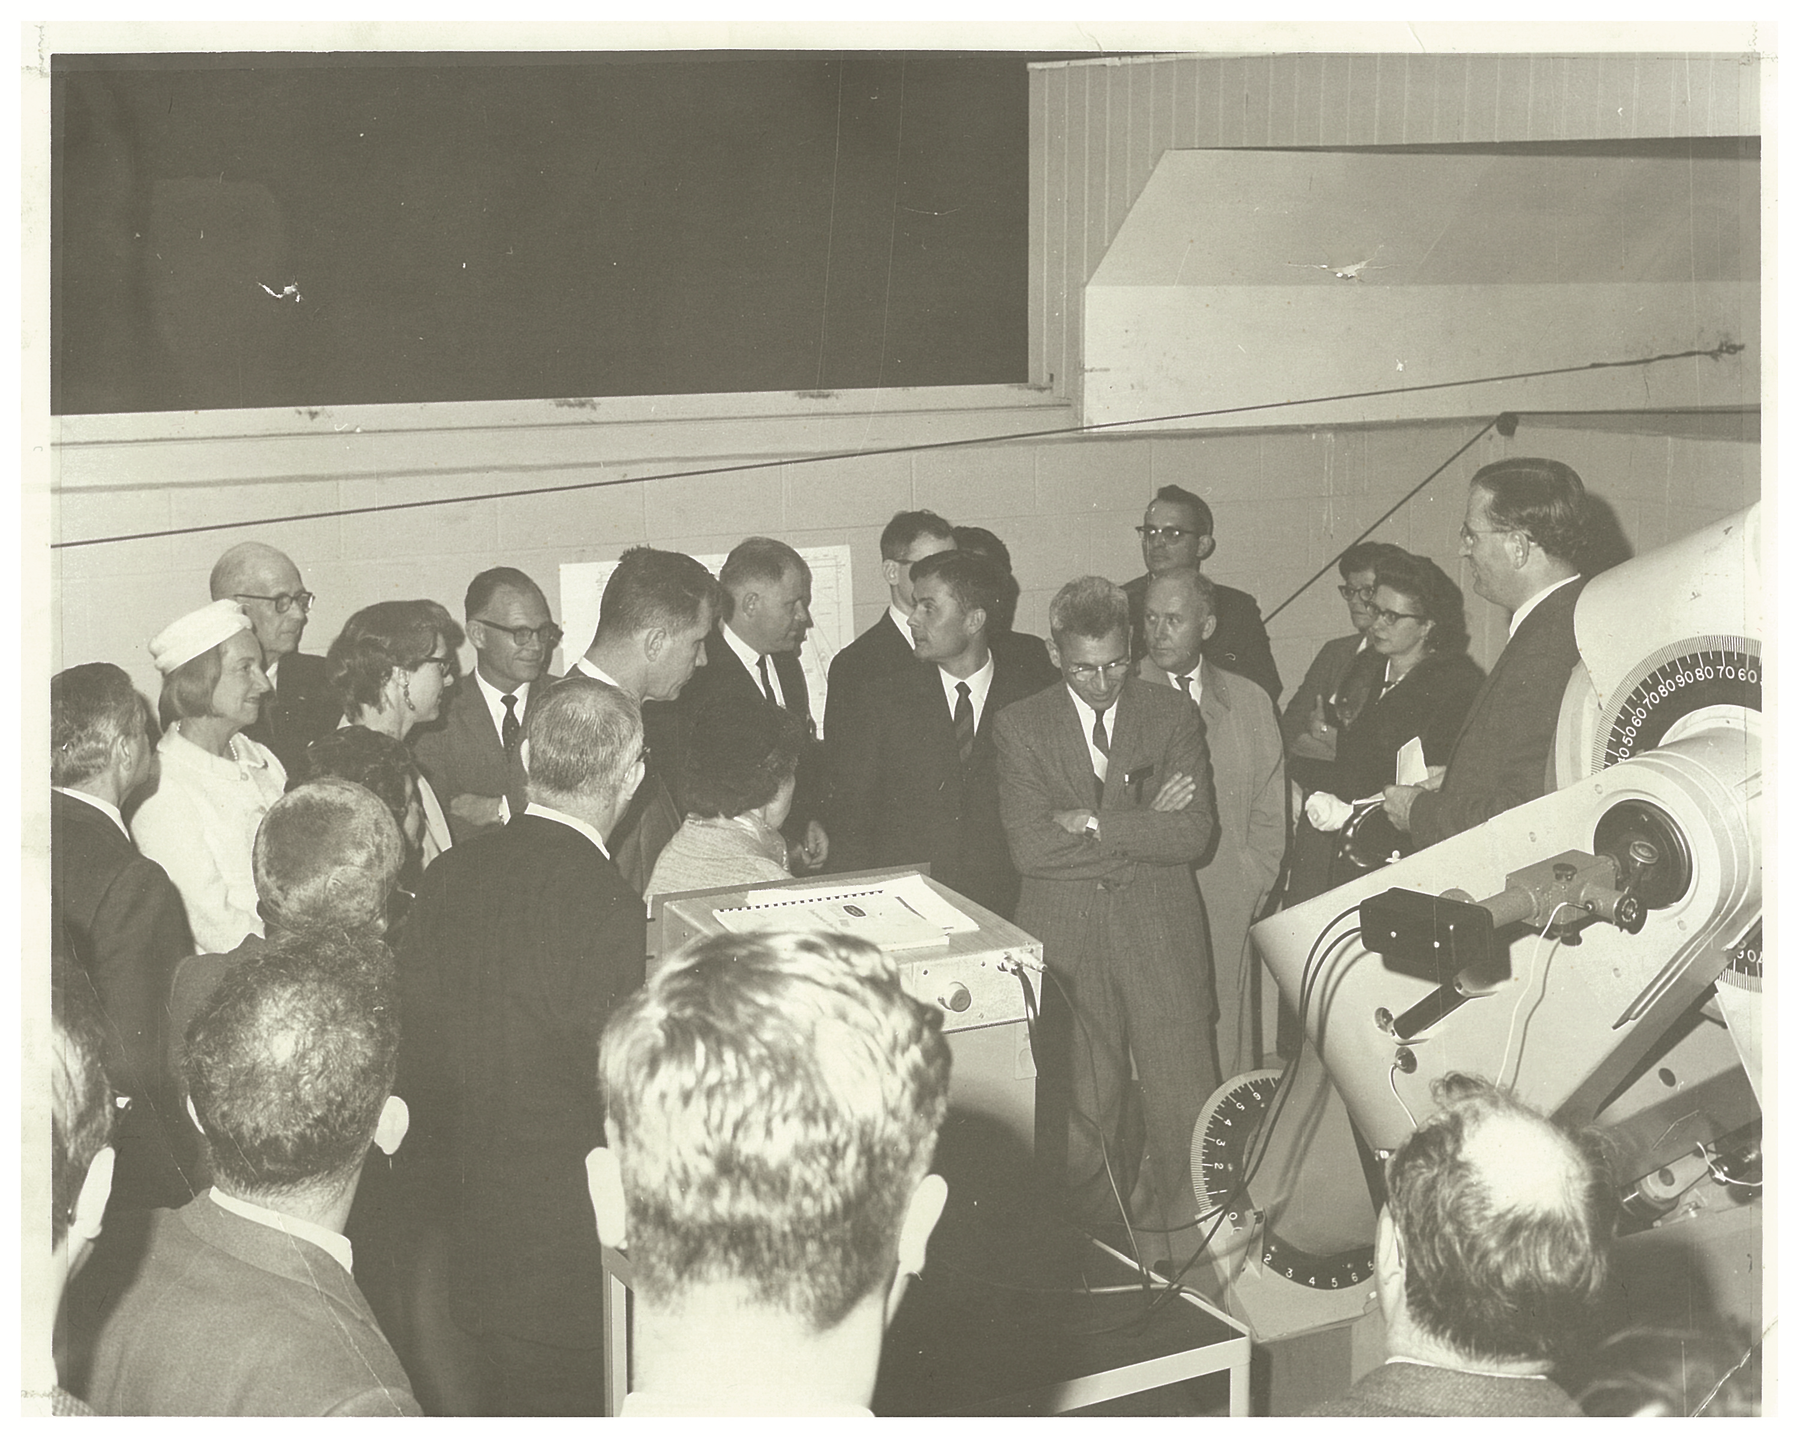
Figure 1 Observatory Dedication

The site was chosen to be near campus to facilitate class usage and to minimize maintenance costs although this placed it in a fairly bright sky area. It was located in a slight declivity in order to rely of trees shielding some of the light. While this resulted in some loss of sky coverage to the north it preserved views in the south and west where the more interesting astronomical objects were located.
The original building consisted of the west bay which housed the 20” telescope, the central bay which housed support facilities. The central bay had darkroom facilities as well as a sidereal clock and star charts. There was a small kitchen facility in the central bay.
In addition to the observatory, there was a trailer located to the south of the main building. This housed some additional support equipment as well as some sleeping quarters. It had been moved from the main campus where it had been used as overflow student housing.
The cost of the observatory is listed as $60K including the building and the equipment. (This would be close to $500K in 2014 dollars.)

In the press story (which appeared Nov 1964 in the Baltimore Evening Sun) the research aims were
1. Movements within clouds of hot gas some 1,000 light years away to better understand the formation of stars.
2. The ”pulsating” light of certain variable stars to discover more about their temperature conditions.
3. The scintillation of starlight
4. The study of dust in the upper atmosphere

BUILDINGS
The east bay was expanded to house additional telescopes. This was likely due to the recognition of the difficulties of accommodating a growing number of students with one or two telescopes. The expanded east bay initially had a raised floor in the rear (east) side to enable easier access to the telescopes. Eventually with newer telescopes (and longer focal lengths), this became an encumbrance and the raised floor was removed.
In 1977 the lecture building was added east of the observatory to accommodate classes and the growing open house program. In addition, a concrete pad with permanent pedestals was added east of the lecture hall to provide space for portable telescopes to be mounted for observing classes.
There have been ongoiong efforts to improve the lecture hall. It took several years to remedy the build up of moisture on the interior walls of the building. Air conditioning was added in 1997 at the same time that the heating system was changed from oil to propane.
The old trailer was replaced with a newer model in 1997 . The new trailer largely houses support materials for the observatory and open house and outreach programs.

TELESCOPES
The major telescope was the 20” reflector which was funded in part by the National Science Foundation. It was designed by Uco van Wyck who was the Assistant Director of the Astronomy Program (Fig. 2). The telescope was built by the L.C. Eichner Company and was installed and aligned in the summer of 1964. This was a period in which observing instruments tended to be large and heavy and photography was on glass plates. As a result a very heavy mount was designed to provide stability. While this was an appropriate design at the time, it has limited the flexibility on upgrading the telescope. Cf figure3.
A major overhaul of the instrument occurred in 1999. This involved renovation of the mirror and the drives. The telescope was removed for over a year during the renovation. Despite this effort, drive problems have persisted.
The remaining telescopes have varied through the years. At the time of dedication, there was an 8” reflector in addition to the 20”. By the 1970’s there were three telescopes in the expanded east bay. These included an 8 “ refractor on loan from NASA, a 10” Schmidt Cassegrain and a 12” Cassegrain. The east bay telescopes in the 1970’s can be seen in figure 4
The current telescopes include the 8” refractor just mention as well as a 7” reflector and a 14” refractor. These are described in the observatory website.

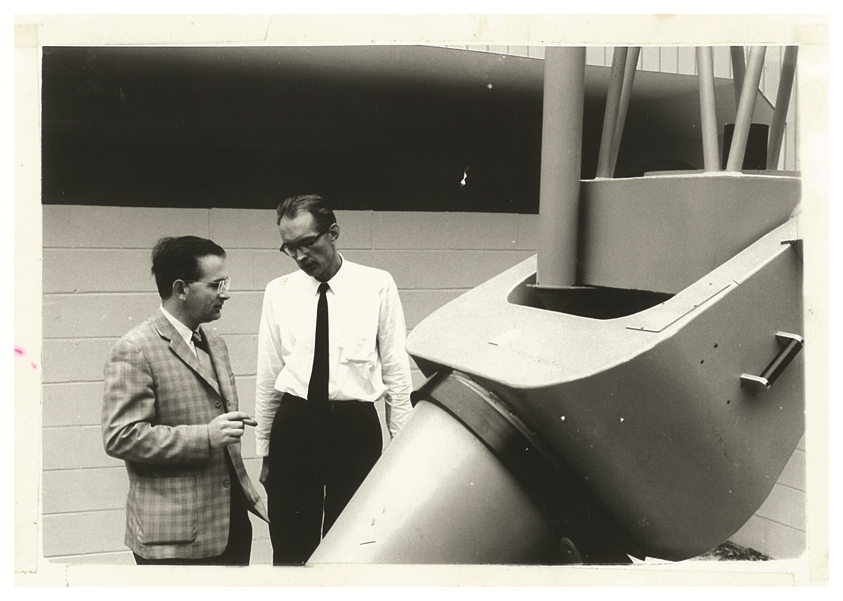
Figure 2 Gart Westerhout (left) and Uco van Wyck (right) with the 20” telescope.

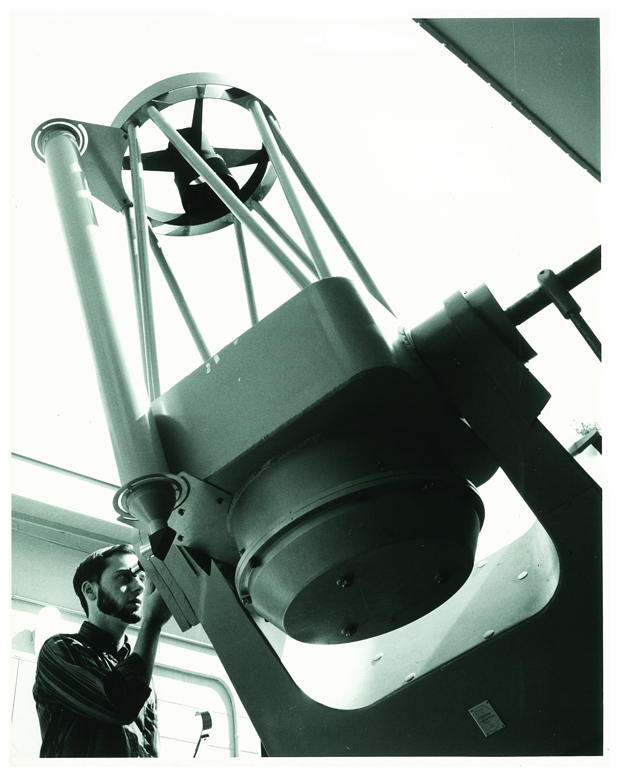
Figure 3 The 20” telescope

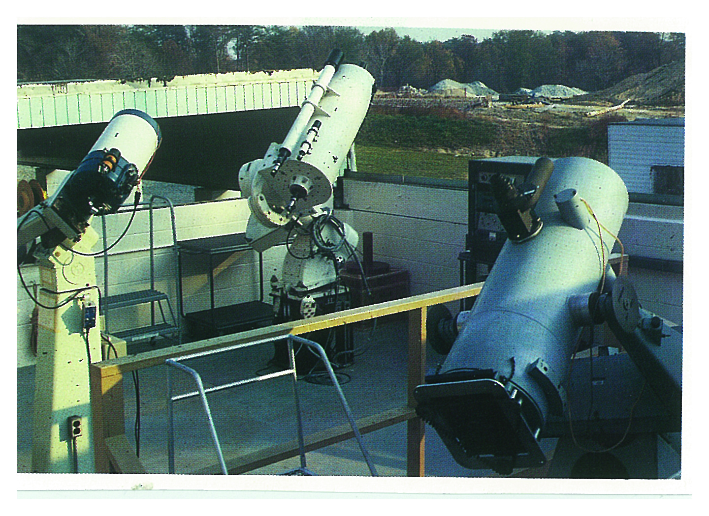
Figure 4 The East Bay in the 1970’s

ACTIVITIES AT THE OBSERVATORY

RESEARCH
The report on the observatory at the time of dedication, laid some stress on faculty research. Of the topics mentioned above, the one that had the most impact was instrument development. In particular, the Fabry-Perot Interferometer was a major instrument and is already mentioned at the time of the dedication. It was realized from the start that while the local observatory would serve as a place for testing instrument, the research use of them would be at darker sites where larger telescopes were available. For a long while, the west bay housed the shipping cartons for these instruments as well as lso canisters of liquid gases used for cooling the instruments down to temperatures needed for observing. As time went on, the first generation of instruments became less cutting edge and the program’s involvement in instrumentation shifted towards radio wavelengths.
It became clear that faculty research needed larger telescopes (and darker sites). Even in 1964 at the dedication of the observatory, the program talked of obtaining a 36” telescope to be housed in the east bay. By 1969, they had developed a proposal for a 36”-40” telescope to be located somewhere in western Maryland. By 1972, there was a new proposal for a 60-90” telescope to be located somewhere in the southwest. By 2012, the now Department of Astronomy became a partner in the Discovery Channel telescope which has a 4.3m aperture and is located near Flagstaff, Arizona.
The College Park Observatory has ceased to be used for significant research efforts.

EDUCATION
Education on both the graduate and the undergraduate level was seen as an important role for the observatory from the start. Funds for the 20” telescope were provided in part by an NSF grant for undergraduate education. All Astronomy majors were required to do an observing project. The expansion of the east bay and the acquisition of additional telescopes were probably motivated by difficulties in handling a large number of students with a single telescope.
On the graduate level, it was felt that familiarity with telescope operations was an important aspect of a career in astronomy. As time went on and the nature of observational astronomy changed, experience with a relatively small telescope became less valuable. The emphasis shifted to gaining experience in observational work by accompanying a faculty member on an observing trip to a large (and modern) facility. By the 1990s, the observatory had ceased to be used for graduate education.
On the undergraduate level, first hand experience with how observations are made and the sorts of uncertainties (and errors) involved in obtaining data were considered important learning objectives. An observing course continues to be required for all undergraduate astronomy majors. Ongoing problems with the 20” telescope have led to increased reliance on the telescopes in the east bay.
Various attempts have been made to use the observatory in the general education classes. There was a class specifically designed for non-majors and some small portable telescopes were obtained for this class. This does require a significant outlay of resources and personnel for a relatively small number of students. There were also logistical problems with getting the students to the observatory. Ultimately, this class was eliminated from the schedule.
There have been efforts made to encourage students in the large survey classes to attend one of the open house programs and this continues to be the case. However, this represents a relatively large pool of potential attendees and this can easily overwhelm the public open houses.

PUBLIC OUTREACH
While there is no mention of public programs in the articles on the observatory dedication, the open house program was begun by 1969. From the onset, these were on the 5th and 20th of the month as they are at present. It was decided to fix the days of the month and to allow the programs to rotate through the days of the week in order to accommodate persons with specific scheduling constraints. The original open houses were in the central bay of the observatory and comprised a talk by an astronomer followed by telescope viewing. As the popularity of these events grew, there was recourse to borrowing a tent from the army and setting it up to the east of the observatory (just beyond what is now the lecture building). As noted previously, the lecture hall was added on 1977 partially to handle the open house programs and partially to support class activities at the observatory. While statistics have not been kept carefully, it is estimated that close to 50,000 visitors have come to the observatory since the inception of the open house program.
In the early days, the open house programs were organized and run by a graduate student as the equivalent of a Teaching Assistant position. As time went on and there was less expertise among the graduate students in operating the telescopes and a loss in continuity by having new coordinators every year or two. Since the 1990s, there has been a person hired part time to run the observatory programs.
Public programs have been expanded in recent years to include a new telescope owners session where people can bring in their own telescope and get hands on tutorials in how to use them. This normally occurs in January and has proven to be very popular.
We have also added a summer course which aims at providing an understanding of how to find you way around the night sky.
There is also an ongoing collaboration with Northwestern High School which is close to campus. Interested students can do projects at the observatory.
Anyone who has been at the observatory realizes that parking is highly limited. For major events, this requires alternative strategies. Some examples occur below.

SOME PROBLEMS ALONG THE WAY
The somewhat isolated site of the observatory and the design of the building have occasionally resulted in problems. There have been several break ins at the facility. Most of these occurred in the 1970s and usually targeted the old trailer which as it deteriorated was an easier target for theft. The items usually taken include small telescopes, binoculars, tools etc. There was one occasion involving a break in at the observatory itself involving going through the wooden roof. Legend has it that the thieves were attempting to unbolt the 20” telescope. When this telescope was removed for refurbishing (1999), it required a crane and a flat bed truck. It is unclear what the potential thieves had in mind.
The sliding roof design of the observatory building has led to other problems. In the late 1960’s, a graduate student inadvertently let the roof of the east bay move beyond its normal stopping point. The roof fell off the tracks and required a crane to lift it back. This also led to greater care in developing limit switches to prevent a reoccurrence.
The sliding roof also requires careful alignment of the cables with which it is moved. It is worth Quoting in detail the report of an incident which occurred on September 20, 1975. The report is by Dennis Welnitz the graduate student then on charge of the observatory open house.
“ I had opened the roof of the west by at 20:00 in case the clouds then present cleared. At about 21:15 a few drops of rain began falling and Steve Lange (another graduate student working the observatory that night) began closing the roof of the west bay. ….. he was standing between the 20” telescope and the north wall of the bay. There was no one else in the bay as all the visitors were listening to the talk and slide show being given by Dr. Virginia Trimble in the lecture room. The roof was closing normally and making no abnormal noises. Then Steve saw a crack appear in the south wall of the roof and immediately went over to the switch and turned off the motor. He then came into the lecture room and told me. …. We immediately went outside and discovered that the roof supports were bent and the columns had fallen down. The roof itself had twisted in a counter-clockwise direction as seen from above. ……. The roof and the west bay structure continued to make crackling, straining sounds for about 5 minutes, then appeared settled. Closer examination revealed that the two outermost columns had tipped completely over, closer columns had broken off and were leaning, the rails on which the roof runs had been badly bent, the top course of cinder blocks of the south wall if the 20” bay had been broken loose and shifted, and the roof itself had been broken up and torn apart in various places.”
More careful inspection of the columns and support structures has occurred since then and no repeat of the event has occurred.
There has also been an ongoing dialogue concerning the space to the immediate south of the observatory site. This is under the jurisdiction of Physical Plant and acts as a temporary storage site for objects removed from the main campus e.g. old lampposts being replaced by newer models. It also attracted private individuals who used it as a dumping ground until improved fencing was installed. The department has frequently complained of the visual impact this has on visitors to the observatory. There is a memo from Physical Plant indicating that when the site reached full capacity, it would be covered with topsoil and allowed to revert to a natural state. At that time it was estimated that the landfill has a future capacity of 12 to 24 months. The memo is dated November 29, 1984.

RADIO ASTRONOMY AT THE OBSERVATORY
Given that many of the faculty at the department do research in the radio/mm wavelength range, it is not surprising that there have been efforts to introduce radio astronomy at the College Park Observatory. Early on, a 20ft radio telescope was obtained from the National Radio Astronomy Observatory. This was installed near where the roadway off of Metzerott Rd entered the observatory grounds. This was only the dish and the plan was to develop the necessary electronics. Unfortunately, this never materialized and the dish was later disposed of. The have been several attempts to build radio interferometers for use at the observatory. At one point, a two element interferometer was installed on the roof of the Computer and Space Sciences building on campus. In general, these efforts were not long term successful. Observations were limited to seeing the sun and a small handful of the brightest sources. The remains of the latest attempt are in the fenced in area between the lecture hall and the observatory.

SOME CHALLENGES
Since the observatory is on University grounds but hardly in the center of campus, it has been vulnerable to various suggested projects. The proximity to the golf course does provide some level of protection from some expansion projects although this presented a possible problem when there was a discussion of a highly illuminated driving facility near Adelphi Road. On the other hand, the popularity of the golf course was a saving factor recently in derailing the hotel facility discussed for the area. For some time, it was also possible to make common cause with the gravity wave observatory which was located nearby. (It was straight down the entrance road from Metzerott Rd.) However, this facility has long since been discontinued.
There have been two serious challenges. The first occurred when the University entered into discussions with the US Archives to locate part of their research facility in College Park. There was some discussion about locating the facility right off of Metzerott Rd (basically on the observatory site). The actual location has its main entrance on Adelphi Rd. There were lengthy discussions about potential problems arising from lighting. In the end, lighting from the Archives building has not been a major problem for the observatory and the existence of this building provides a buffer against other expansion in that quarter.
Potentially more serious was a proposal to relocate a baseball field from campus to the area where the Physical Plant Holding Facility is located – adjacent to the observatory. Since the site is limited and there are minimum size requirement for the field – not to mention having sufficient parking available, this presented a potentially serious threat to the observatory. In addition, when night games were being played, the observatory would be unusable. In the end, the Athletic Department decided not to pursue this. In all likelihood, the site would at best have been marginally acceptable for them.
In the course of these several challenges, alternate sites for the observatory were explored. At one stage, there was a potential for relocating the facility to Sugarloaf Mt near Thurmont, MD. However, while this would have been a darker site, the distance would basically eliminate the public programs and probably much of the education efforts. The decrease in ambient light would not have been sufficient to compensate for the other losses. At a later stage, alternate sites closer to campus were looked at. The only site that was seriously considered was at the high point on the wooded area to the north of the dormitory facilities which are north of the Computer and Space Sciences building. This neer got past the talk stage. In the end, the development of the basketball stadium would have seriously compromised that site.

SPECIAL EVENTS
It is probably best to conclude the story of the observatory with some discussion of highlights. Parking limitations at the observatory make it challenging to have big events there. When this has occurred, the observatory lot is reserved for workers and handicapped parking. Others are directed to park at the UM System Admin parking lot which is across Metzerott Rd from the observatory. This also requires hiring police aides to control traffic on Metzerott Rd. So, if at all possible, big events have been held on campus where there is better parking and where it is possible to attract students who would otherwise be unaware of the event. Small portable telescopes can be brought from the observatory to campus and contacts with the local amateur astronomy community usually guarantees several larger portable telescopes show up. Lunar eclipses, a partial solar eclipse, bright comets and the transit of Venus have all been observed from different campus locales. Probably the biggest event in terms of turnout was Comet Hale Bopp (1997) which drew well over 1000 persons over several nights.
The observatory itself has been the site of several special events. The discussion here includes three rather different events which showcase what can be done.
The first was the apparition of Comet Halley in 1986 The appearance that time was a rather poor one. Even through a telescope, it appeared as a small fuzzy object. It was also an early morning site in the winter. Nevertheless, it is the best known comet in history and not to be missed as a public event. The observatory was open to the public several nights/morning to look at the comet and hundreds of people showed up for the events. As a pleasant coincidence, one of the persons who turned up was the dean of the college – surely a happy occurrence for the department.
The second event occurred in 1994. Comet Shoemaker Levy 9 broke into several pieces due to gravitational effects from Jupiter and the pieces were projected to collide with that planet. There was considerable speculation as to how visible the results of the impact would be. Again the observatory was open to the public (parking across the street). Several talks (attendance by ticket only) were given at the lecture hall. The public and the media turned out in large numbers. The impact scars were clearly visible and everyone appeared to enjoy the event. On a personal note, I was running a teacher workshop at the same time with 25 teachers from around the country attending. They got to participate in the event as a special enrichment experience. More pleasantly, the event was visible as soon as it got dark and so you did not need to get up at 3 AM.
The last event to be mentioned here was the opposition of Mars in 2003. While these oppositions are fairly common events, this was to be the closest opposition in a thousand years and there was not to be another one this close for another millennium. (The actual time spans varied with reports but were all many human lifetimes.) The event got substantial media coverage. Unfortunately, it occurred in a very cloudy and wet period of time. All the early scheduled events at the observatory were rained out as they were at other locations in the area. When a good night finally occurred, the crowds turned out. The line for the telescopes stretched out of the observatory up the hill to well passed the lecture building. It then looped back down the hill towards the observatory and then looped again back up hill to nearly the road. The wait was close to 90 minutes. Even when people were told the length of the wait and told that the visual appearance of Mars would not be different from what would be seen at the next regular opposition in a few years, they were willing to wait. Many hundreds got to see Mars that night. The observatory stayed open until the clouds moved in. Even then, the diehards waited and were rewarded when the clouds broke in time.
These three events have different characteristics but all showcase the popularity of astronomical events. The observatory plays an important role in education at the university but an even more important role in public outreach. Hopefully, it will still be functioning when Comet Halley makes it next appearance in 2060. It is expected to be a more impressive sight than it was in 1986. Of course, if you are truly optimistic there is the following apparition of Comet Halley which is projected to be truly spectacular – in 2134!

