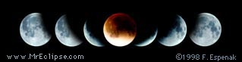
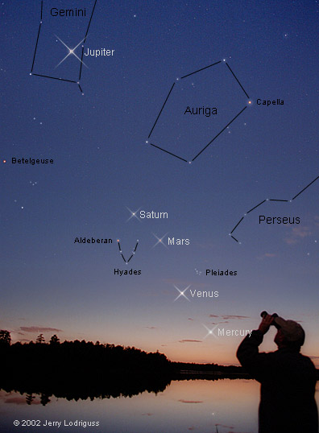
Space Chats Lunar Eclipse
Star Party
Wednesday, October 27, 2004
Goddard Visitor Center 7:00 – 10:00 p.m.
Total eclipses of the Moon are remarkably beautiful events and are completely safe to watch. Bring your binoculars and join the Goddard Astronomy Club to view this graceful celestial ballet as the Moon swings through the Earth's shadow. Hope for clear skies, dress warmly and enjoy the show!

7:00pm For the Children: Free 10X Refractor Telescope Kit!
Visitor Center personnel will provide brief instruction on the basic components of a telescope, and then help the children assemble the kits.

7:30pm- All About Telescopes: Types: Pros & Cons; Getting Quality
9:00pm Martin (“Marty”) Cohen, Company Seven, Laurel, Maryland

All Evening “Ask Your Question”
Members of the GSFC Astronomy Club will be on hand to provide practical advice on how to get started in astronomy. (How to use a star chart; locating the planets; using your telescope; observing tips etc.)
Members will also be set up outside with telescopes to view the moon and other bright astronomical objects.

9:00pm Lunar Eclipse Tutorial
A member of the GSFC Astronomy Club will present a short tutorial on the geometry of a lunar eclipse and take questions

9:15pm Moon enters earth’s shadow
While there is no fee, registration is encouraged. Register online at http://www.gsfc.nasa.gov by clicking on “Space Chats.”
Contact Michele Jones at 301-286-8102 for further questions.

