

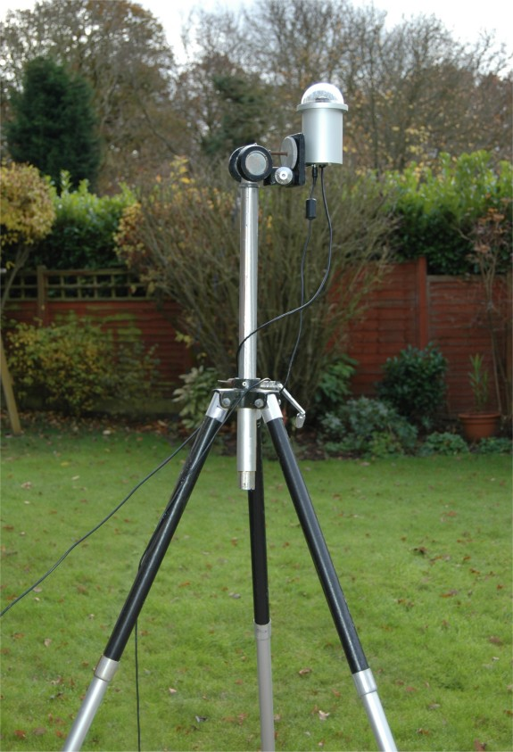
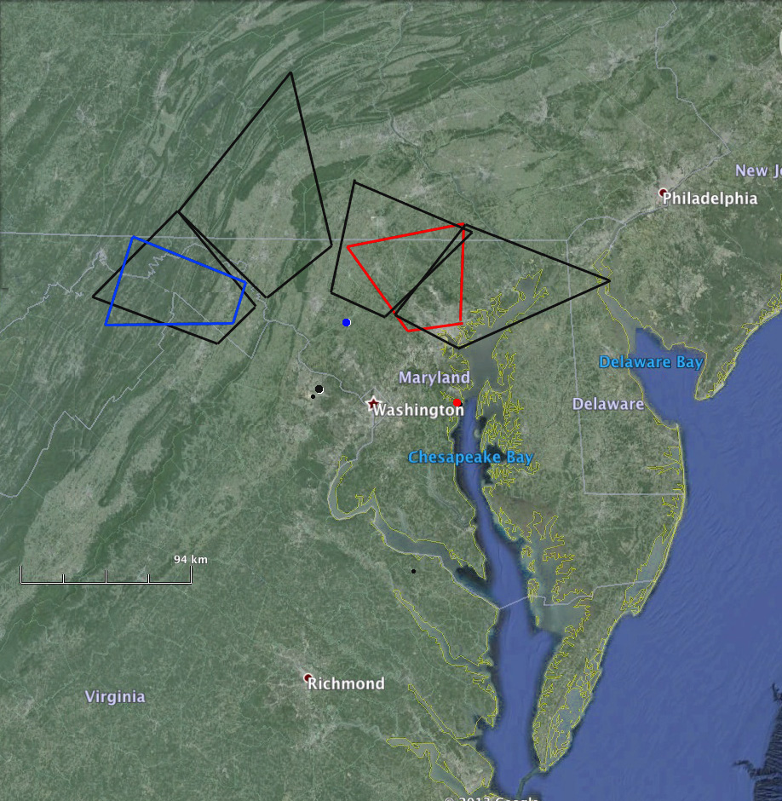
Build the Maryland All-Sky Network!
Steven Ryan
stryan@terpmail.umd.edu
PURPOSE
The purpose of my Capstone project was to raise money for and help set up the required camera systems for the University of Maryland Observatory's All-Sky Camera Network.
Background
This project was done for the University of Maryland Observatory under the guidance of Elizabeth Warner of the UMD Astronomy department. The reasoning behind purchasing the cameras was that the across the state of Maryland there are multiple All-Sky cameras active. However in the area around UMD and Montgomery College there were no cameras, leaving a “dark spot” in the night sky. Thus our plan was to fill this “dark spot” and provide the image data to the general public through the internet.
Method
We chose to use UMD's own official crowd-sourced funding platform, LaunchUMD, to raise money for the project. The platform allowed us to easily manage the various task required, such as sending out updates on the project, accepting donations, and keeping in touch with possible donors and those who had donated.

After purchasing the cameras we then set then located the best places to install them using Google Maps, star-charts, and input from our donors.
Results
The fundraising portion of the project was a resounding success, in that we not only reached our goal of $5000 for two cameras and their accompanying systems but also reached and overcame our stretch goal of $7500 allowing us to purchase a third and fourth system. We successfully set up the cameras in their various locations, including the Observatory itself and at Montgomery College. Finally, we accomplished the task of setting up the camera systems to send their image feeds to the internet at the Observatory website.
Conclusions
We found that the project was far more interesting than we originally thought since we raised over $2500 in the first two days. Thanks to generosity of our donors and the help of GRAD-MAP and Montgomery College we were able to successfully fill the “dark spot” of camera footage of the Maryland sky and provide free access to the data we collect.
References
http://www.sxccd.com/oculus-all-sky-camera
With Special Thanks To
Elizabeth Warner, GRAD-MAP, AstroTerps, and all our donors
4

