Assembly notes for the WASP2 microwave processing modules

Downconverter module
AH 15.1.03

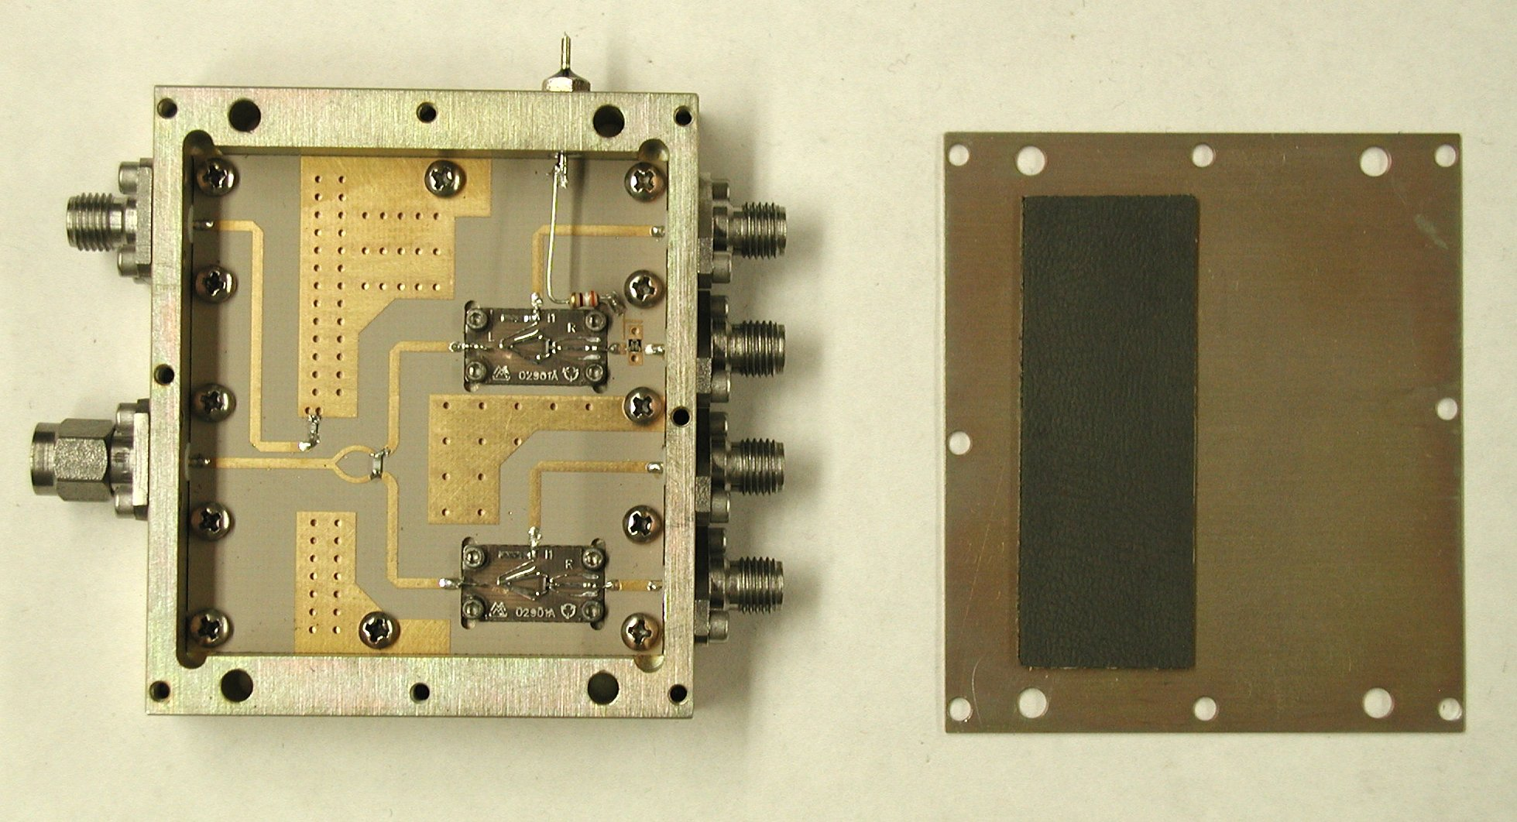
Figure 1: Overview of downconverter module with cover and absorber. When the top is on the absorber is above the mixers and signal lines.

- Run the circuit board edges against a flat file for slip fit in housing. Check that mixer substrates are an easy fit in the mixer cutouts.
- Solder or glue 100 and 50 ohm resistors into place: 100 ohm 0603 size across the splitter, 50 ohm 0402 size as the directional coupler termination. Use 600 C fine iron, tin one side first (not ground for directional coupler), solder one end of resistor, then return with solder for second side.
- Glue the Hittite HMC 136 modulator chip in place with silver epoxy. Apply a small dab of epoxy to the circuit board with a needle, drop the chip in place gently press the chip top with tweezer tips to distribute epoxy under chip. The chip surface has exposed metalization that is easily damaged, so be very careful to apply pressure only to the corners of the chip surface. Epoxy should flow under chip but should not be higher than the chip surface – otherwise, there is some danger of shorting the bond wires. Figure 2 below shows the correct orientation. Cure in large aluminum box in oven following epoxy data sheet (for Bondline 2900, 1 hr at 150 C). Aluminum box keeps the chip clean and eliminates the chance that it will be blown off position.
- Wire bond two wires between each RF bond pad and the microstrip traces, and one long wire between the bias pad and bias circuit board trace. To get good clearance on the bias lead make the first bond on the chip pad, then lift the tool high before traversing to the second bond on the circuit board. Figure 3 below shows the board orientation for reasonable vacuum clamping, although the board is not held very securely.
- Put the circuit board in the housing and attach with 12 2-56x3/16 phillips head machine screws.
- Drop Marki Microwave M1-0408LE-1 mixers into the two cutouts on the circuit boards. Attach to housing with 4 0-80x1/8 socket head cap screws (0.050 key) for each of two mixers.
- Insert a center pin into a spacer bead for 6 each EMC modular connectors, 1/8” wall.
- Slip beads into housing wall. Solder each pin in place with rosin core solder – best orientation is with pin axis perpendicular to you and solder region toward you. Flow solder under pin, then reflow while pressing pin toward board if necessary. Use a short section of solder cut from the spool – this makes it easier to keep the solder wire clear of the assembly when it’s not actually being used, minimizing the chance of incidental damage to the modulator chip or the mixers.
- Make solder connections between the mixers and the circuit board traces. Use rosin core solder and a bridge of #30 wire (wire wrap wire). Bend a ~ 1 mm right angle into wire’s end, solder in place, and cut long tail with small sharp wire cutters.
- Cut pins on modulator bias feedthrough to about 5 mm on both sides. Screw into housing wall and tighten with a 1/4” nut driver (black handle). Bend leads on 1/8 W 390 ohm resistor to connect pin and circuit board contact pad. Bends close to resistor body with 0.1” leg down and small foot to pad on circuit board. Leave leg to pin long; solder to pad first, then cut remaining leg to fit and solder to pin.
- Snap EMC connectors onto pins and attach with 16 2-56x3/16 socket head cap screws (5/64 key). The signal input and outputs take 2-hole female jacks; the LO input a 4-hole male plug; and the LO monitor a 4-hole female jack.
- Cut a 5/8” wide by 2” long strip of Eccosorb MCSU/SS3 self-adhesive microwave absorber material. Attach to housing top cover over signal inputs. Note that the cover is not quite symmetrical, so verify that the holes line up properly before attaching absorber.
- Label other side of top cover: In 1, Out 1, In 2, Out 2, LO, Mon, Mod.
- Attach top cover to housing with 6 2-56x1/4 slotted pan head screws.

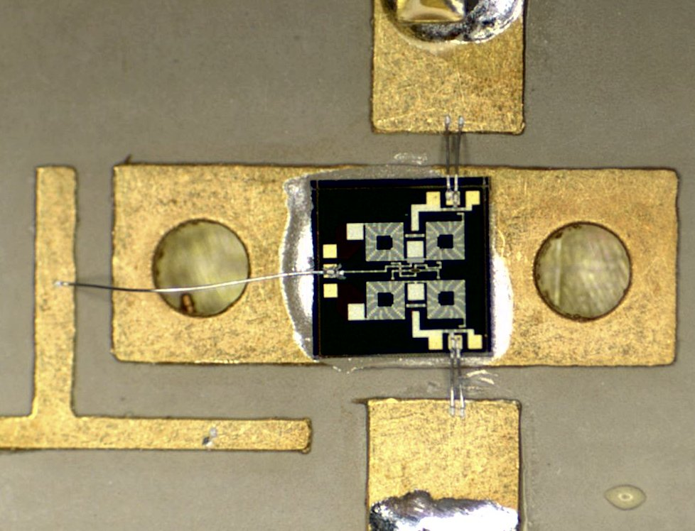
Figure 2: Phase modulator placement and bond wires. The chip should be slightly to the left of this position.

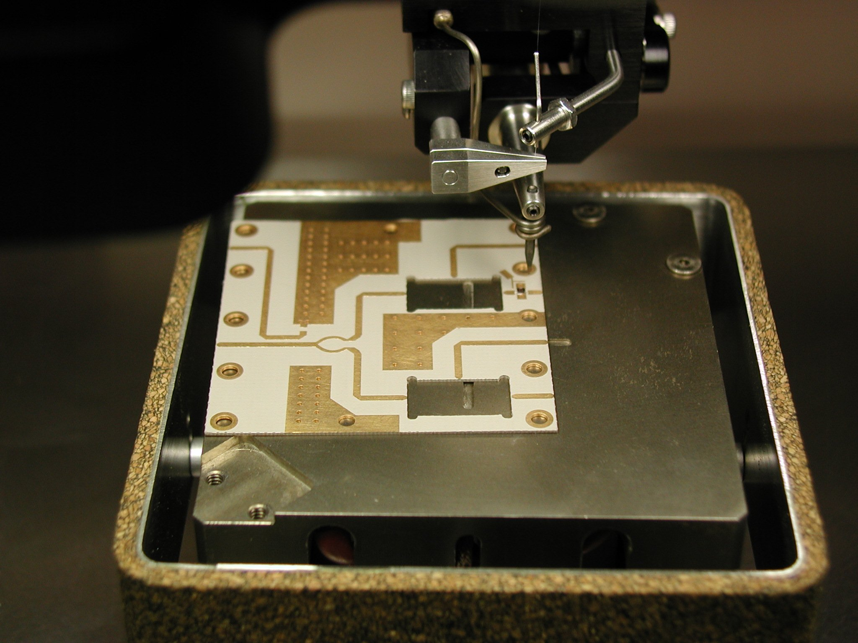
Figure 3: Bonder setup showing positioning for vacuum clamping

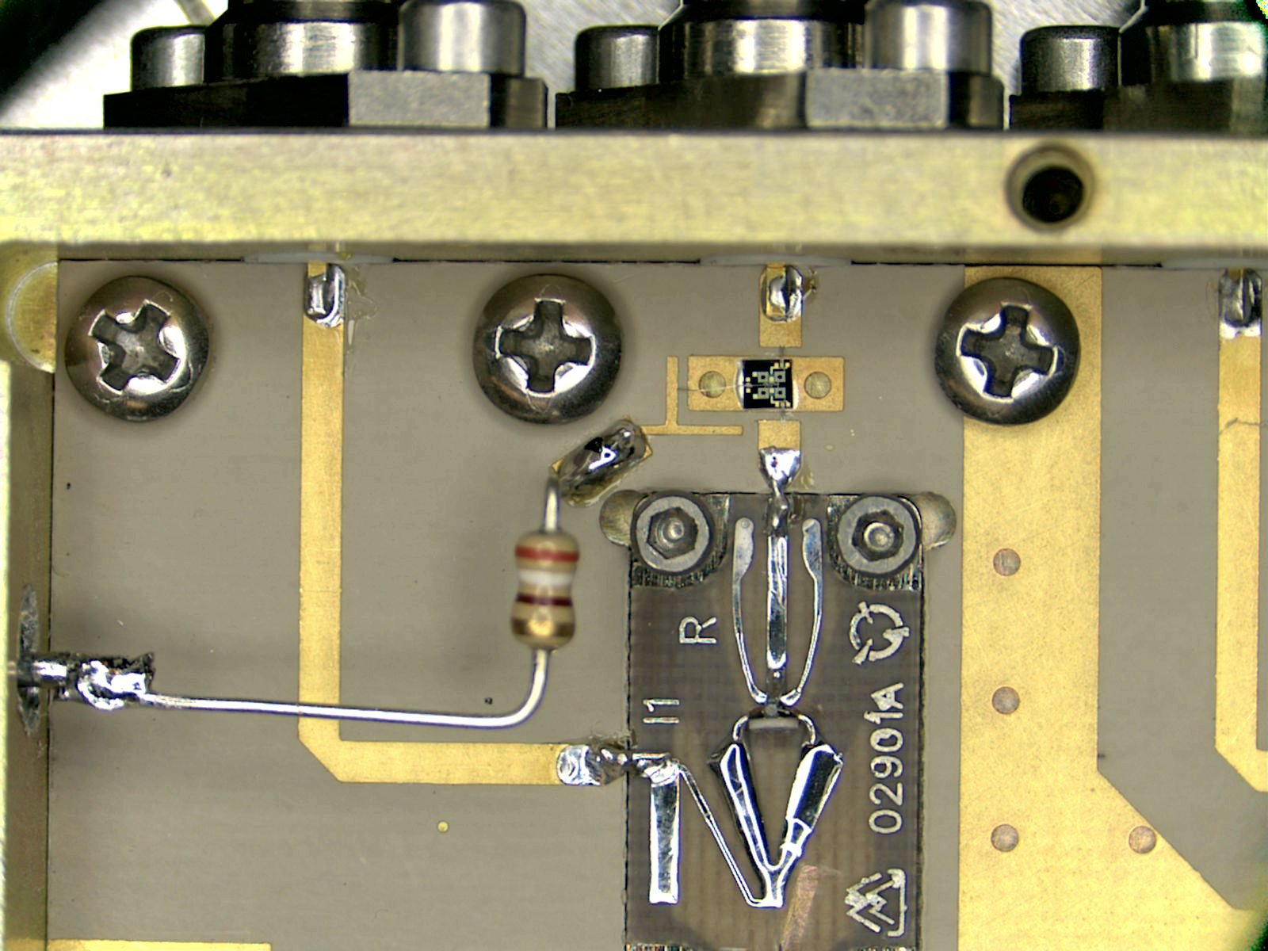
Figure 4: Phase modulator and mixer in downconverter module.

Downconverter plate assembly
AH 15.1.03

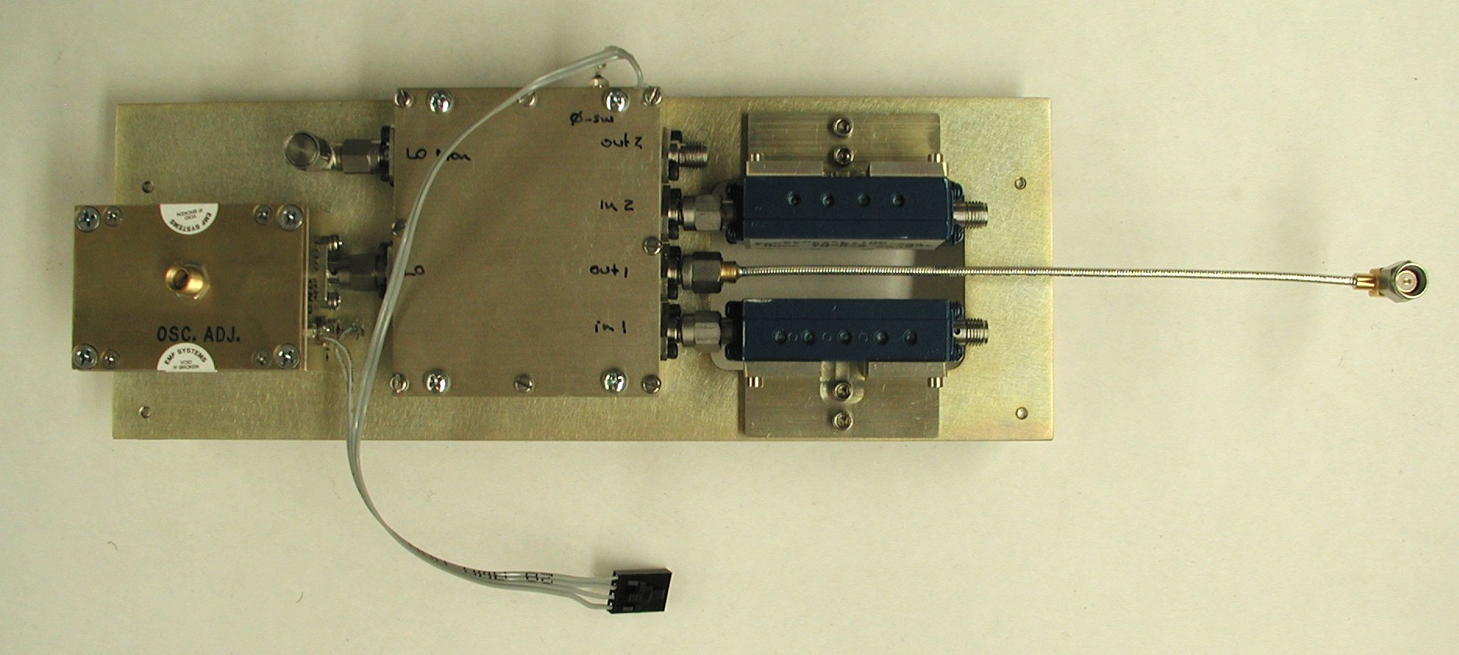
Figure 5: Assembled downconverter plate.

- Connect DRO and downconverter module – use plate for flat surface.
- Insert 4 4-40x1 flat head phillips screws through DRO (outermost holes), 4 4-40x5/8 phillips head machine screws through downconverter module. Tighten DRO screws, then downconverter module screws.
- Attach filters to inputs and snug but do not tighten SMA connectors.
- Loosely attach bracket to plates with 2 4-40x1/4 screws and 2 2-56x1/4 screws to the filter.
- Snug up bracket screws, tighten SMA connectors, unscrew bracket screws to relieve stress, and retighten bracket screws. Repeat process until all screws and connectors are tight with low stress.
- Attach angle brackets to back side of plate with 2 4-40x1/4 socket head cap screws, two angle brackets per plate.
- Prepare 4-wire ribbon cable, 7” long, with female locking Molex connector. Split ribbon cable to 1 cm with small diagonal cutters. Strip 3 mm insulation from ends with simple stripper. Lock female pin in crimper with spring-loaded locking mechanism; but wire end up to mechanism and crimp. Repeat for wires in cable.
- With locking mechanism down, cable toward you, from left to right connect ribbon cable to: DRO power, DRO case, modulator drive, modulator case. Insulate “hot” pins with shrink-wrap tubing.

Amplifier module board
AH 30.1.03 (from memory)
- Bond step attenuator and switch ground planes to circuit boards with silver epoxy or solder. If solder, tin board, then heat from below with properly sized fixture (which we don’t have) on hot plate.
- Solder step attenuator and switch pins to board with small iron (600 C) and 0.020 solder or with solder paste and hot air.
- Clean carefully with acetone – solder paste may remain under pins. Inspect under microscope.
- Tin ribbon cable contact pads and associated isolation resistor pads with Supersafe flux and solder on Weller soldering iron (600 C). Tin one side of switch isolation resistor pads and termination resistor.
- Reflow solder to connect one end of 10 kΩ (0402) isolation resistors and 50 Ω (0402) termination resistor with small soldering iron.
- Solder other end of isolation and termination resistors with small iron.
- Tin one end (not common end) of 0402 case resistor and inductor pads in equalizer network with Supersafe flux and small iron.
- Reflow solder to attach 4 ea. 56 Ω and 2 ea. 68 Ω (0402) resistors, then use wire solder to attach other ends.
- Reflow solder for 2 ea. 2.2 nH (0402) inductors. Pads are too small, so this takes some work.
- Tin one side of gap for capacitor with Supersafe flux and small iron.
- Hold 1.3 pF capacitor (ATC100 series) with metal tweezers, reflow solder to hold capacitor in place. Correct orientation is with narrow side down (tall capacitor), but it doesn’t seem to matter in this application.
- Solder other side of capacitor in place with wire solder and small iron.
- Add solder to first side as needed.
- Wash circuit board with warm flowing water to remove flux.

Gain module
AH 28.2.03 to 12.3.03

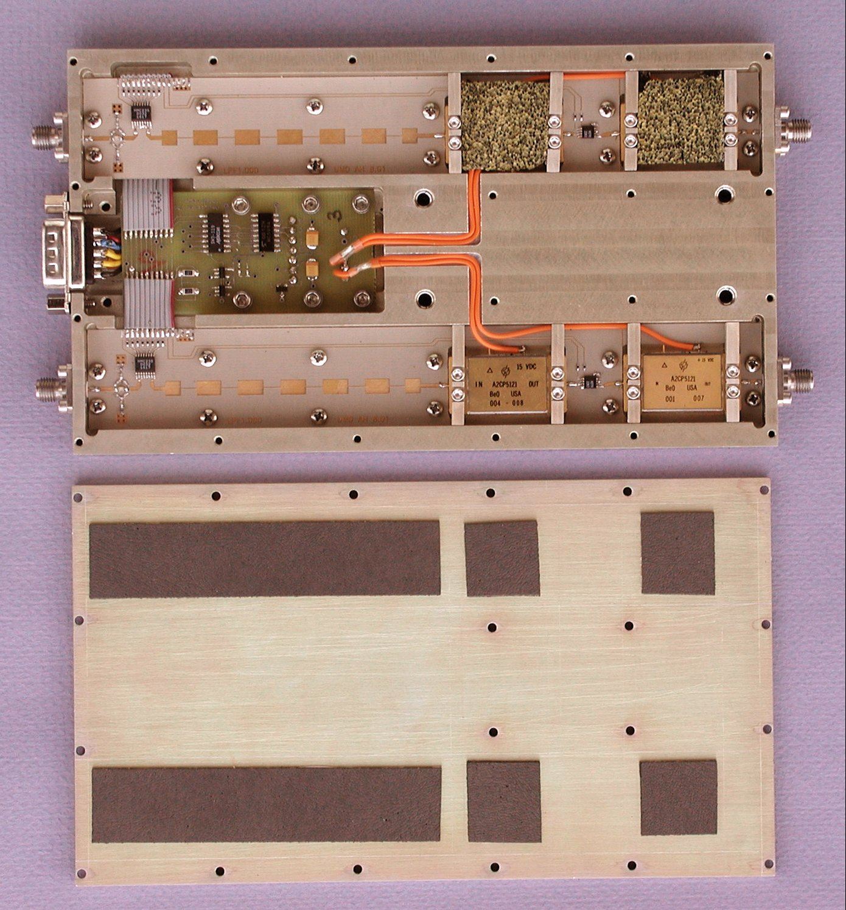
Figure 6: Amplifier module and cover

- Check microwave and interface boards for mechanical fit.
- Cut wires to ~3” and solder to interface board:
  - Red +5 V
  - Blue –5 V
  - Black Gnd and +15 return
  - Orange +15 V
  - Yellow else
- Drop board in place, install 9-pin D-submin male connector (5 pin side up), trim wires for ends at shell ridge.
- Dismantle, solder wires to connector.
- Attach board temporarily with 2 ea. 4-40x1/4 soc hd cap screws
- Tin ribbon cable pads on interface board using #30 Supersafe flux. Tin ribbon cable pads on microwave boards if necessary.
- Cut 10-conductor ribbon cables to 0.60” and 1.85” lengths. Strip ends with custom stripping tool ~0.05” long.
- Tack to microwave board pads with fine soldering iron and Supersafe #30 flux, then add solder as necessary.
- Drop into housing, tack to interface board pads with fine soldering iron and Supersafe #30 flux, then add solder as necessary.
- Remove circuit boards and connector from housing. Wash flux region with warm flowing water. Rinse housings. Let dry overnight.
- Drop board assembly into housing.
  - Attach interface board with 6 ea. 4-40x1/4 soc hd cap screws.
  - Attach connector with 2 ea 4-40 screws with threaded caps and lock washers.
  - Attach microwave boards with 24 ea. 2-56x3/16 phillips head cap screws.
- Drop in Cougar amplifiers with heat sink compound below; “tack” in place with 2 ea. 2-56 screws from original housing.
- Trim 15 V wiring from interface card to length.
- Cut wires for 15 V wiring between amplifier pairs. Wire length is 1.80 in insulated with 0.15 to 0.20 in stripped ends. This is for #2 at present; #3 has separate wires running from the interface board to each amplifier. Both wires fit snugly in 0.125 wide, 0.060 deep channel.
- Solder 15 V wiring to amplifiers.
- “Walls” fasten with 2-56x3/8 soc hd cap screws.
- Add EMC connectors, attach with 16 ea. 2-56x3/32 soc hd cap screws.
- Eccosorb AN72 pads: 1” by 7/8” on top of amplifiers (half thickness); 1.25 by 2.5” in interface cavity (full thickness)
- Eccosorb MCSU/SS3 self-adhesive urethane-based absorber: 0.5 by 3.5” over filters, 0.5 by 0.75” over each amplifier.
- Attach cover with 20 ea 2-56x1/4 soc hd cap screws.

Interconnect ribbon cable
AH 17.3.03

- Cut AWG 26, 20-conductor ribbon cable to 10 3/4 in length.
- With red band at top, attach 9-pin submin-D female connector facing up on right-hand end, 20-pin IDC with center key facing down to left hand end. Center key faces out.
- On right-hand end, peel back 3 in, clip out next conductor from submin-D, leave four conductors, clip away remaining 6.
- Attach Molex male pins to group of four wires with locking tabs facing up.
- Snap on 4-pin Molex locking shell, hole for locking toggle up, pin 1 closest to submin-D connector.
- Put strain relief on 20-pin IDC connector.

